Java 7 Features
Auto Closable Try block - Ramesh
Any resource (files, streams, sockets, and database connections) that was successfully initialized, a corresponding invocation to its close) method is required. This requires disciplined usage of try/catch/finally blocks to ensure properly closing of the resource.
We can declare the resource with the try block. Any resource declared within a try block opening will be closed automatically.
Ex:
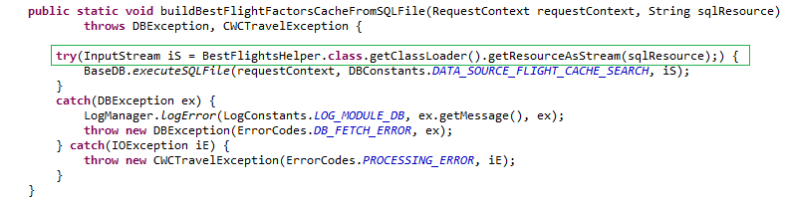
String in switch case statement - Gopinath
We can use string in the switch case statement. But advantages are limited.
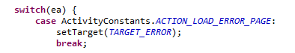
Identifying the places in the number
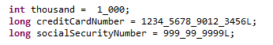
It is just improvising the readability.

To - Do items
- In case of resource failure auto close, previous versions weren’t closing/releasing resources.
- List out resources – find out where we can apply this. XMLUtil, FileUtil etc
- How about handling Interfaces – auto closable.

Clubbing exceptions - Shahid
To – Do items
  - Objective : reduce number of lines – Sonar – code coverage
  - When to use: Empty catch blocks, similar functionality under catches, same logging, same messages
  - Don’t use: when functionality is different like logging at different level
  - Order of exception catching? (Dev note make sure this order)
Strings in Switch : Please see above
- Advantages – readability, reduces code
- Disadvantages – lengthy strings into Request, network overhead
Derby improvements - Sharan
Path API – java.nio – explore in project - Pramod
Fork & Join – Thread Implementation - Suneeta
- Unicode 6.0 – explore features
- Currency Codes – explore
- Swings – spreadsheet enchancements
- Compressed OOPS – 64 bit

Template
Structure of each feature
- Advantage
- Disadvantage
- Sample code from project – Do’s, Don’ts
- Identify usage locations

